A Report ON

B-TECH [AUTOMOTIVE DESIGN ENGINEERING]

Acknowledgement

I thank Prof. Pankaj Kumar Sharma who advised me to stick to my strengths and take up simulation as a project.

I would like to express my heartfelt gratitude to Dr. Ugur Guven for his invaluable guidance, help and encouragement in completing this study. Dr Guven’s direction has helped me develop myself as a Design Engineer with the right attitude. To put it simply and emphatically, Dr Guven was the lifeline of this simulation.

I thank Providence for leading me to the right person at the right time.

I thank my family for their unquestioned support and conviction in my abilities and destiny.

College of Engineering
University of Petroleum and Energy Studies
Dehradun

CERTIFICATE

“Absolute Success can be derived only through a burning desire to constantly challenge yourself to beat your own efforts.”
1.Overview of the Simulation :
This is a simulation of the combustion dynamics inside the combustion chamber of a CI Internal Combustion Engine. It has been done with the objective to analyse the combustion characteristics of Liquid Diesel and Compressed Bio-gas (enriched to 60% methane). The idea is to try and understand the mixing characteristics of Diesel and Bio gas and formulate inferences to optimize the combustion dynamics and hence the engine efficiency.

Multi phase flows are extremely complex to analyse due to the involvement of a large number of phenomena at one instant. This particular simulation even more so as diesel is in the liquid form and Bio-Gas and air are in the gaseous form. These two fuels are completely different in their physical and chemical properties and physical states. It is difficult to predict how exactly the mixture will form and the concentration and the density of the mixture at different points inside the model.

2. Preliminary Decisions made in this simulation :

2.A.Why Use CFD techniques ?

Computational Fluid Dynamics (CFD) is an multi-disciplinary branch of science which determines a numerical solution to the governing equations of fluid flow while advancing the solution through space and time to obtain a numerical description of the complete flow field of interest. The growth of computational power in the past few years has caused a drastic increase in the usage of CFD solutions in various fields, including and especially automotive design.

Computational Fluid Dynamics can be applied to a wide spectrum of engineering applications. CFD techniques enable us to model physical phenomena that cannot be easily simulated or measured through a real world experiment. This simulation of Combustion Dynamics is a good example , as it is difficult to know what exactly happens inside the combustion chamber.

2.B. CFD Softwares used in the simulation:

The softwares used are: Gambit (v 2.2) and Fluent ( v 6.2.3 ) .
Gambit and Fluent basically come together as a package. Gambit is a pre-processing modeling and meshing software which makes maximum use of Fluent’s solving capabilities. Fluent is a solver.

Fluent is the solver that provides the best accuracy for the flow processes being considered here, i.e. simulating a multi transport mixture about to undergo combustion. It provides the capability to use different physical models such as incompressible or compressible, inviscid or viscous, laminar or turbulent, etc. Geometry and mesh generation is done using Gambit which is the preprocessor bundled with Fluent.

2.C. Discretisation method used by Fluent :

Fluent uses the Finite Volume Method in solving the geometry. The Finite Volume method can be summarized as :
In the finite-volume approach, the integral form of the conservation equations are applied to the control volume defined by a cell to get the discrete equations for the cell. By cell, it is meant the cells formed by applying a grid over the geometry of the object to be analysed. The idea is that the corresponding conservation and governing equations are applied to each cell depending on the flow problem.

3. Formulation of the Basic Physical Models :
There are two inlets to the main chamber where the combustion takes place. One inlet carries diesel . The other inlet is of Air, enriched with Bio Gas as shown in the figure . As the the peak pressure is approached inside the combustion chamber, diesel is sprayed inside along with the enriched air. This simulation model, has been made considering that particular instant when this phenomena occurs and combustion is about to take place.

The models can be put into 2 main categories and therefore so can the simulation :
- Simple Transport Combustion Model
- Multi - Transport Combustion model
Figure 1 and 2 show the schematic diagram :

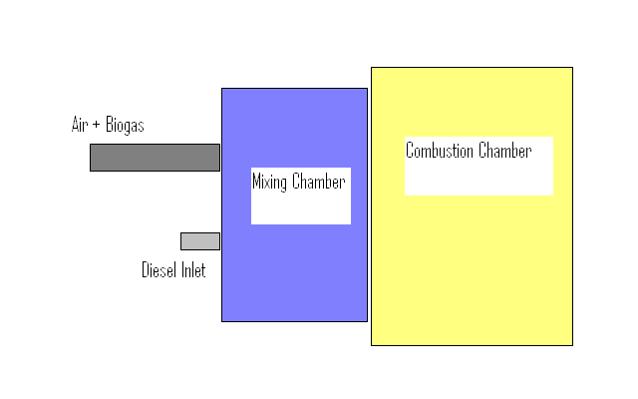
Figure 1 Simple Transport Model block diagram
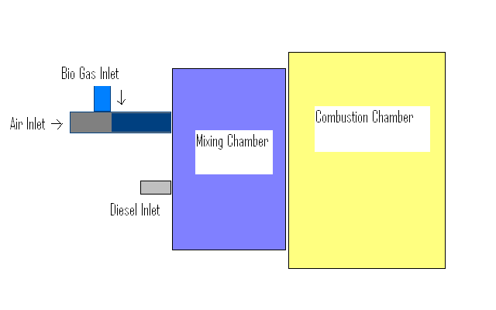
Figure 2 Multi Transport Model Block Diagram

The Simple Transport Models have only two inlets i.e one for Diesel and the other inlet for a homogeneous mixture of Biogas and air. It is a premade homogeneous mixture considering that there is only 1 inlet, but 2 mediums inside already. In this model’s simulation, we don’t consider the complexities of the mixing of biogas and air. We presume a homogeneous mixture.

The Multi Transport model accounts for the fact that in practical situations, we insert biogas into the air inlet controlled through a manually operated valve. The multi transport model also considers the mixing of Biogas and Air before reaching the mixing chamber. This would help us understand to what extent and the characteristics of the the Mixing of Biogas and Air before reaching the mixing chamber. We do not presume a homogeneous mixture here. This increases the complexity of the simulation as this aspect is also added to the simulation process.

A point to note is that, the diesel inlet is much shorter than the Air inlet. This is because Diesel doesn’t travel as much as air and it is atomized through fuel injectors and directly sprayed into the combustion chamber at the point of peak pressure.
To add to this, since we are enriching Air with Biogas, so we must allow them to mix and form a reasonably homogeneous mixture before being mixed with diesel inside the mixing chamber. Inside the chamber, we again require a homogeneous mixture so that a controlled combustion takes place in place of an erratic combustion. Erratic combustion and detonation of the mixture can result in knocking and drastically reduces the efficiency of the engine. At the same time, pollution goes up due to unburnt carbon particles.

4.Modelling and Meshing
Consider a CFD problem, which is with respect to a particular object, say a simple pipe or a cylinder, through which there a fluid flow. Our objective is to understand the characteristics of fluid flow through this pipe. That means, the fundamental Governing equations have to applied to every point of the cylinder to completely understand the flow characteristics.

We divide the model as required using a grid/mesh which is imposed on the model. The point where two grid lines intersect is called a node. The grid consists of several nodes at intervals which we can choose. The required governing equations, and the conditions of the flow, which we can again setup, is solved at all the nodes using a sufficient number of iterations.

We model the geometry and setup the meshing in Gambit. Fluent solves the equations and performs the iterations.

In any CFD simulation, the basic steps followed in solving the problem, is
- Deciding the Geometry and simplifications in the geometry.
- Setting up the Model
- Meshing of the Model including Decomposition of complex geometry.
- Postprocessing (analyzing the mesh quality )
- Setting up the geometry for a solver i.e defining boundary conditions
The mesh quality decides the accuracy of the results. Thus the choice of mesh scheme used is very important for accurate results in fluent.

Point to note :
Extremely accurate modeling is not required in CFD problems as modeling simplifications can be compensated using advanced techniques in Fluent. However , the better the model, the better the results . The meshing done on the model must be analysed by fluent which determines errors in the meshes by doing a quick grid check. If there are errors in the meshing, fluent will not accept the model.

5.Modelling the Combustion Chamber in Gambit :
A top-down with some instances of Bottom up approach has been used. The emphasis has been on proportion and scale of the inlets and the mixing area and the actual combustion chamber itself. For eg the inlet size is about 1/10th the size of the chamber. The more homogeneous the charge inside the combustion chamber, the better are the combustion characteristics and hence a mixing chamber has been made slightly larger than the usual dimensions.

The next few pages will take the reader through the process followed in modeling the combustion chamber in gambit.

Models developed of the combustion chamber :

  - Simple Box Model :
The Box model was first developed to create a simplified model to understand the modeling features in gambit and meshing techniques.
Volumetric meshing of Box shapes are easier to apply without any problems of creating a face for meshing curved surfaces. By Box shapes, it is meant that objects which have no curves in their geometry. This is also because of the various meshing schemes available in gambit. The standard Cooper scheme can be applied only to surfaces that are at approximately 90 degrees to each other. This is not possible in curved surfaces and hence meshing the model becomes complex.

Figure 3 Wire frame of initial Box model

Figure 4 Rendered Box model

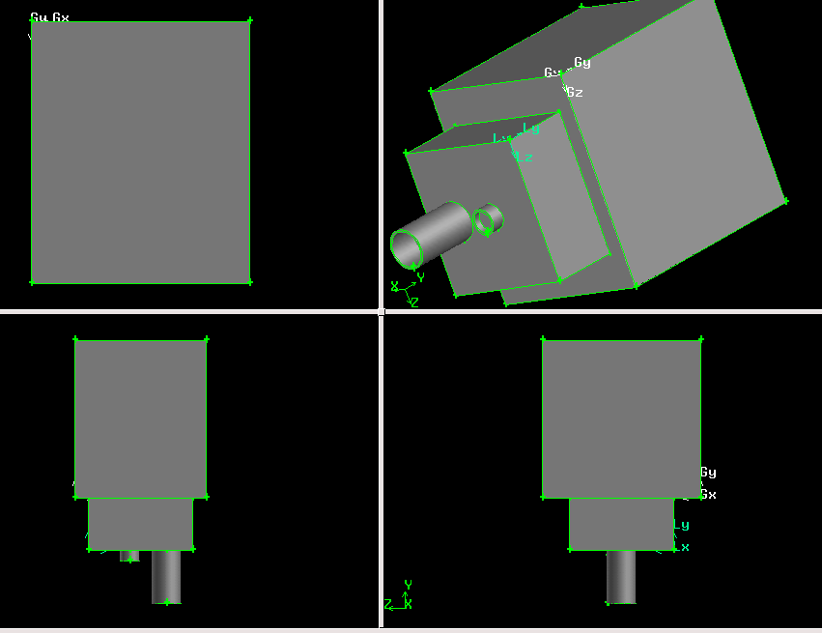
Figure 5 Box model : Views from various Orientations

Meshing : The Cooper meshing scheme was applied to all the surfaces with a mesh interval of 0.5 for good results results.

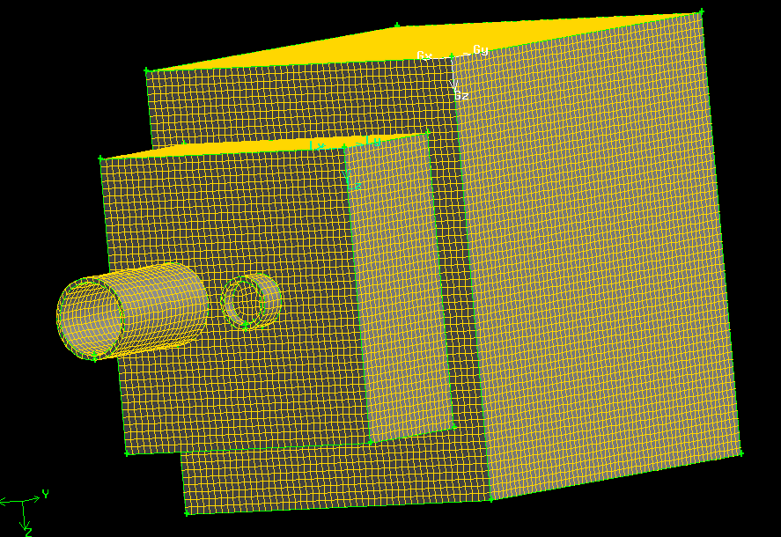
Figure 6 Meshed Box model

A screenshot of a volumetric meshing layer has been shown in figure 7 to get a clearer idea of the job Fluent does. Fluent solves the governing equations at all the nodes formed by the intersecting lines of the grid shown here and that’s not just for this layer, its done for all the layers.
To create a grid manually, we must specify the position and the number and the intervals of the grid points. By this option, we have the choice to mesh complicated parts of the geometry in a different way so as to get better results as the geometry will greatly influence the direction and characteristics of the flow
.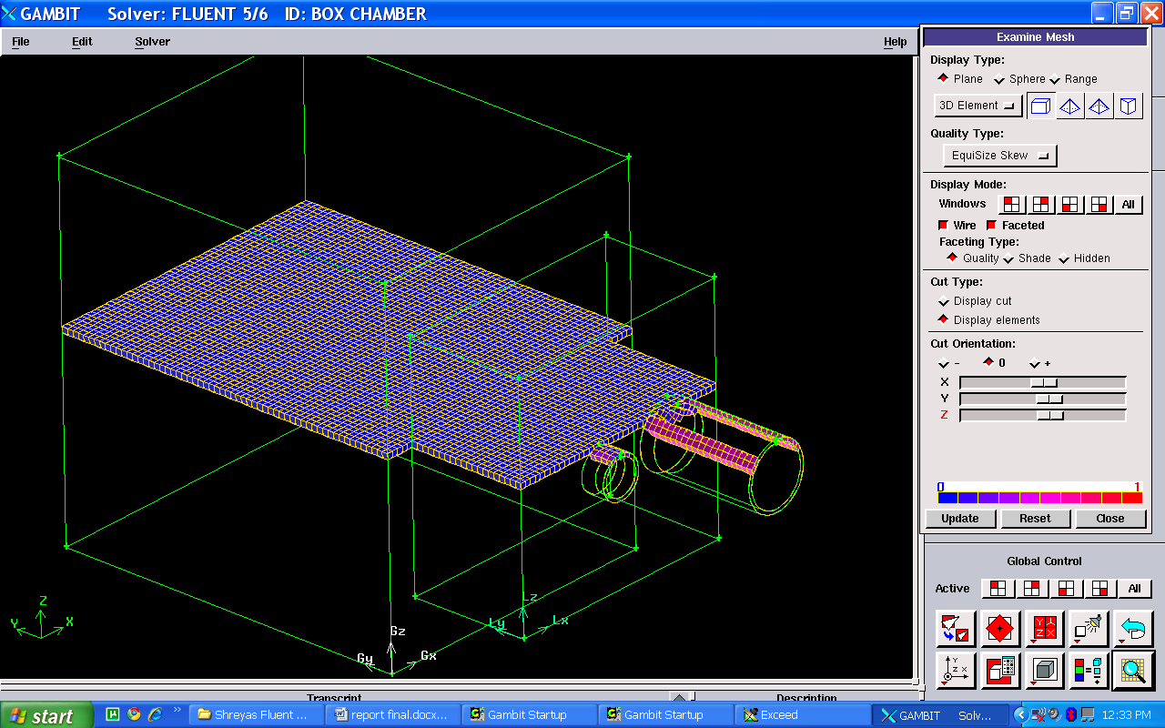
Figure 7 Volumetric Meshing layer shown
The ‘show worst element’ option in gambit enables the user to find the element with the least accuracy in the model. This element can be modified to enable better results and increase the overall skewness of the model.

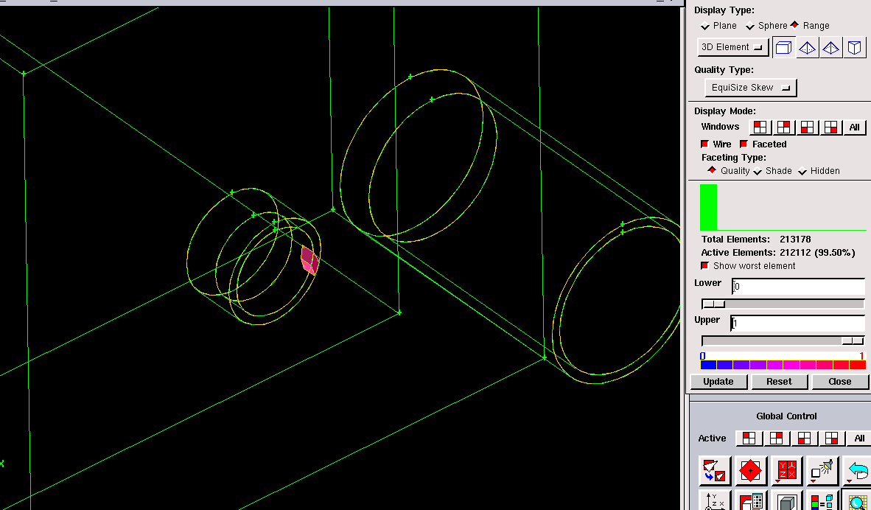
Figure 8 Postprocessing (wost element shown)

5.2 Model 2 : Quarter- Model of Combustion Chamber :
It was desired to have better geometry of the combustion chamber to enable mixing of the fuels in a more efficient manner. However this would involve complex curved surfaces and different meshing schemes on appropriate surfaces. So , 1/4th the combustion chamber was modeled with more complex geometry and applying symmetry.

However the multiphase combustion process cannot be modeled using symmetry as it is too complex. The concept of symmetry does not exist inside an combustion chamber and a combustion process. Especially considering that there is more than one fuel in consideration with completely different physical and chemical properties.

But this exercise helped in understanding basic meshing techniques and decomposing the geometry of complex surfaces. It also helped in further refining the model for more efficient mixing and combustion.

The corners of the box chamber were simply blended with a constant radius of 5. To this 2 quarter sections were attached using various modeling techniques like splitting and Boolean operations.

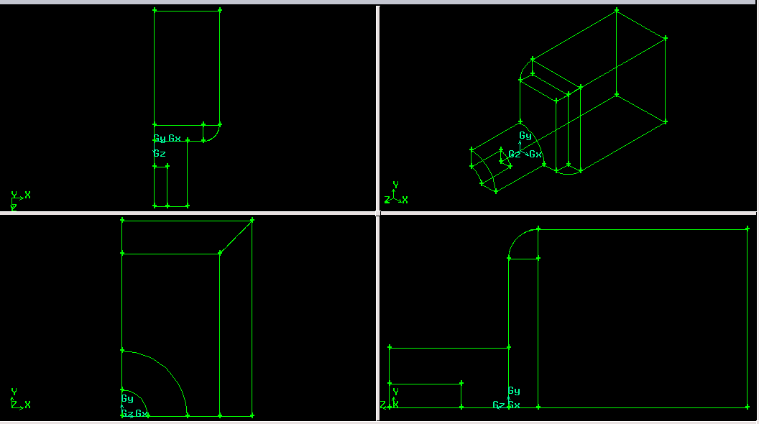
Figure 9 Wireframe views of Quarter chamber
The above wireframe shows the faces that have been created around the blended edge of the Brick like combustion chamber. These faces were created to decompose the geometry of the blend and enable a structured grid meshing over the surface.

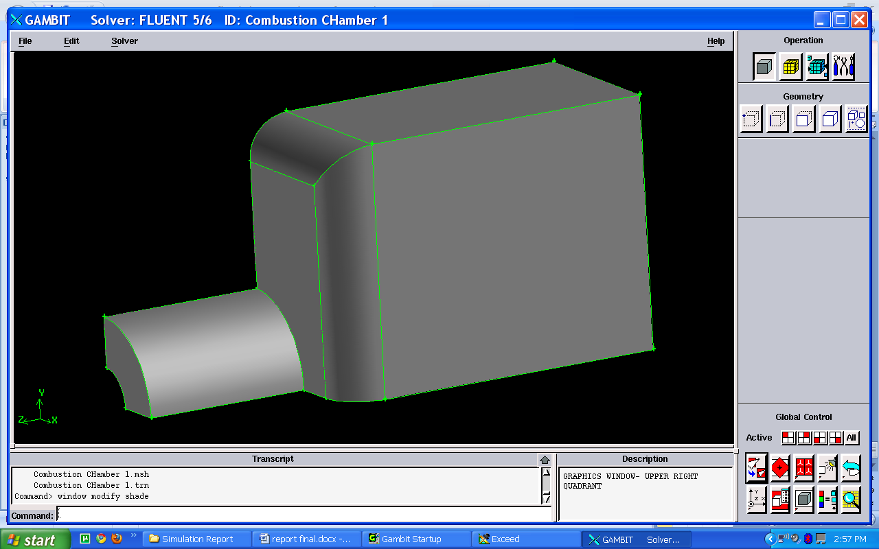
Figure 10 Quarter Combustion Chamber -Rendered Right side view

Figure 11 Quarter Combustion Chamber - Front Isometric
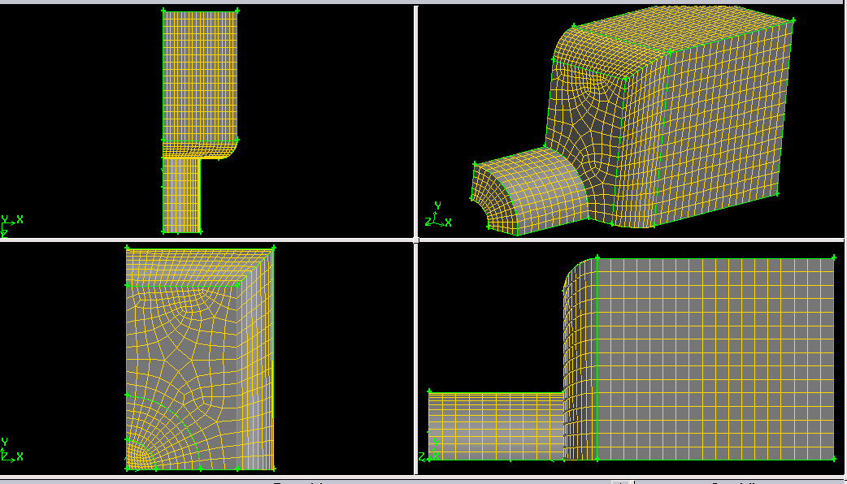
Figure 12 Quarter Combustion Chamber - Meshed Model
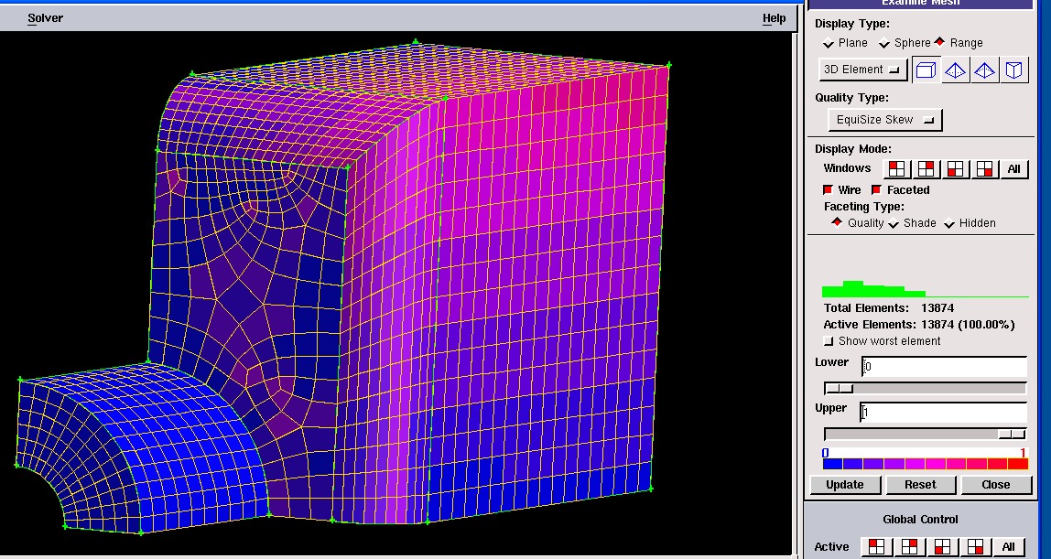
Figure 13 Postprocessing of mesh quality

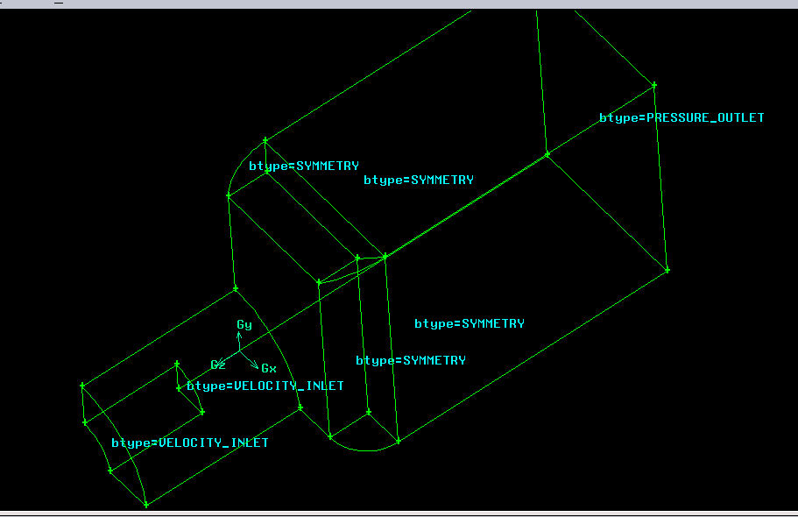
Figure 14 Application of Boundary Definitions
It was felt that , in this model , the inlets were too large considering the size of the chamber. It would be dangerous from a safety point of view as after all, we are analyzing highly combustible fuels which can explode if not handled carefully. Large inlets would mean a large amount of fuel entering the chamber, and thus more turbulence and less favorable mixing characteristics. So the proportions of the model had to be refined further.
It was also decided to enlarge the mixing area of the chamber so as to give the fuels more time to homogenize and facilitate efficient combustion. These improvements can be seen in the subsequent models.

5.3 Model 3 : Final Simple Transport Model :

Figure 15 Wireframe View of the model

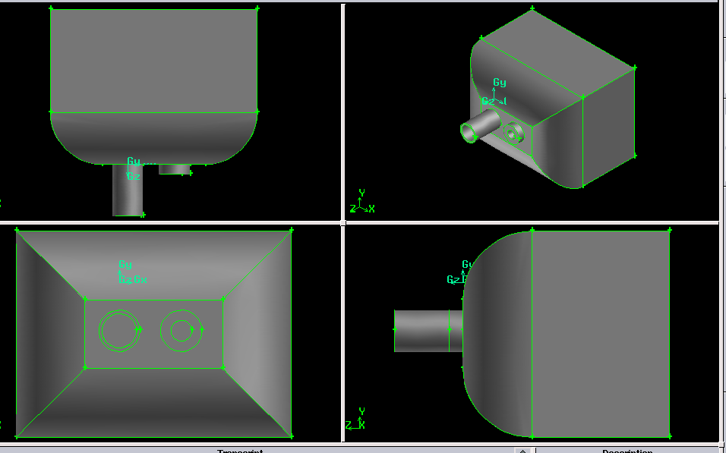
Figure 16 Different views of the Rendered model

5.4 Model 4: Final Multi Transport Model :

Figure 17 Rendered view of the Multi transport model

Meshing done : Tetrahedral /Hybrid type elements with a TGrid meshing scheme. By Tetrahedral/Hybrid, it is meant that the user can insert or modify the default tetrahedral meshes with hybrid meshes at the areas he desires.

Figure 18 Tetrahedral Meshing shown

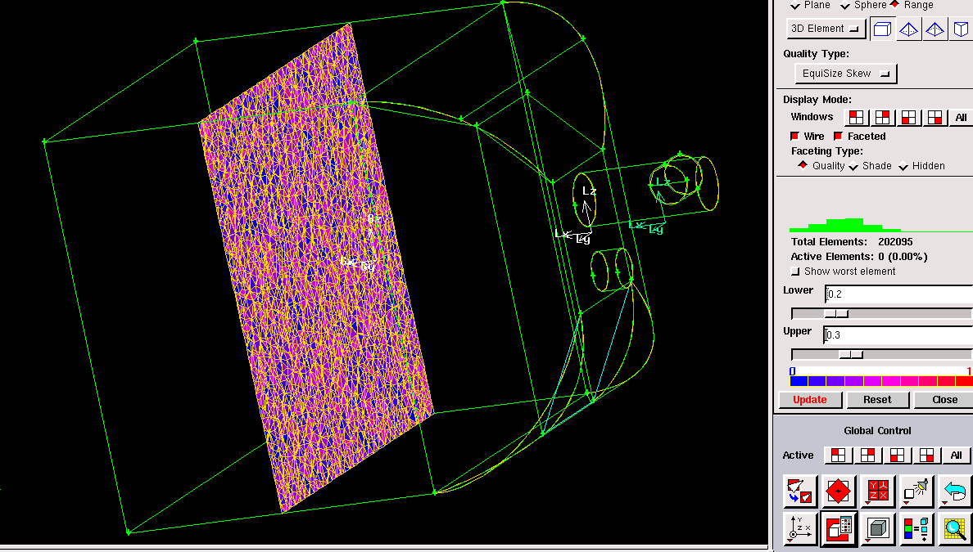
Figure 19 Postprocessing Mesh quality by range

6.Simulation Results :

This simulation has been iterated 1,000 times. The low number of iterations is due to the time constraint of this project. However, it has been attempted to compensate these deficiencies in Fluent using tweaks.The 3 inlets shown for the sake of understanding are Air, Bio Gas and Diesel. All three fluids have been given a velocity of 15 m/s and have been made to the enter the chamber at the same time. The temperature and pressure have been taken at standard values. i.e STP (Standard Temperature and Pressure values) .
The topmost inlet is Air, the inlet inbetween is biogas and the lower most inlet is of Diesel.

The various results obtained have been shown below and the interpretation follows each result :

  - Velocity characteristics in the chamber :

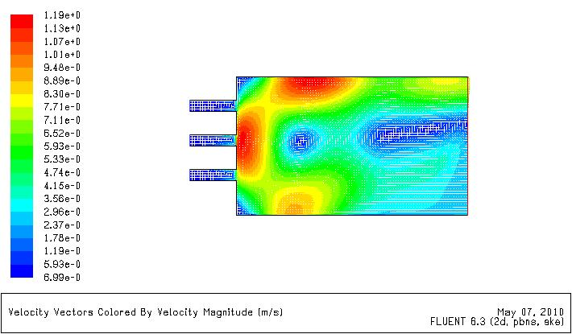
Figure 20 Velocity Vector distribution

This result is a depiction of the velocity vectors of the mixture at different regions of the chamber. The speed is indicated by the color and the color-meter magnitude is shown on the left side.

The three fluids, are entering the chamber at the same velocity and at the same time. This can be verified from the above result. Notice that the 3 inlets have the same color region and hence velocity. The white lines shown are the vectors which enable to see the direction of motion of the fluid. It can be seen above that the fluids,upon entering the chamber are at high velocities due to the turbulence created by the meeting of two different fluids.
Upon converging the fluid velocities have diverged towards the upper and bottom edges of the chamber whereas the central region has a low velocity spot.
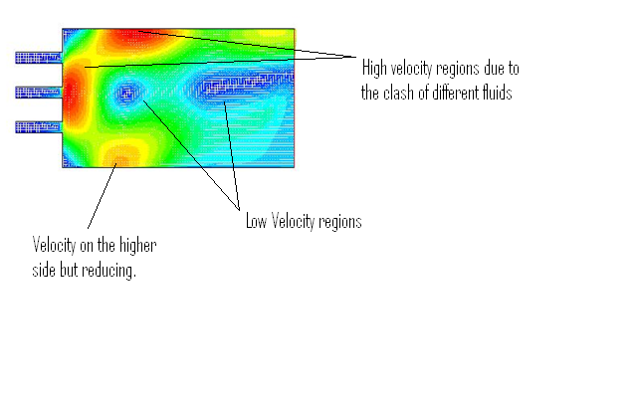
Figure 21 Highlights of the velocity variation

The large variation in the velocities indicate inefficient mixing of the fluids. Notice that the central region of the combustion chamber has mostly low velocity mixture. The objective is a uniform increase in the velocity after the fluids have mixed.
The edges of the combustion chamber towards the left side also consist of low velocity mixture. This indicates that the mixture in these parts are settled due to the continuous flowing of the entering mixture over them. The mixture is thus not being used efficiently and nearly half the mixture is not mixing very well.

The graph in figure 15 shows the variation of velocity over the distance travelled by the mixture in the combustion chamber. The extreme fluctuation of velocity can be seen.
After the initial mixing, the mixture velocity has considerably reduced to just over half the starting value.

The blackened areas in the graph are indicative of the average velocity of the mixture at that particular point. The blackened areas are formed over repeated iterations. The variation in the thickness of the black areas indicate that only a portion of the mixture, possesses the indicated velocity. As we can see, at some points, very small portions of the mixture possess a particular velocity. This is not desirable and indicates that the mixing of the various fluids have not taken place well.

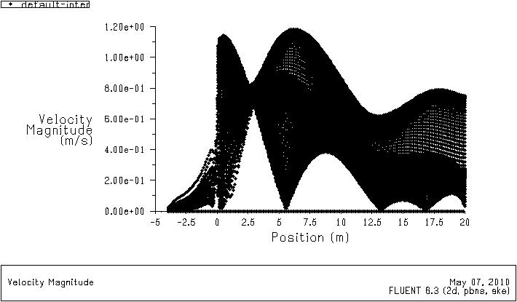
Figure 22 Graph - Variation of Velocity over Distance
After the position of around 5 meters, there is a sharp increase in the amount of mixture attaining a particular velocity and the Rapid fluctuation can also be seen. These characteristics emphasize the instability of the mixture before combustion.
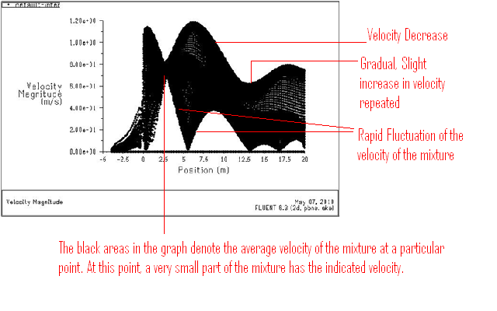
Figure 23 Highlights of the graph
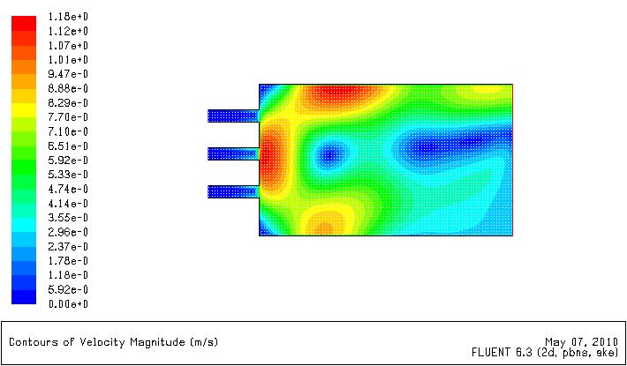
Figure 24 Velocity Contours in the Combustion Chamber

Note : Difference between Contours and Vectors : (Shown in figure 25)

Figure 25 Difference between vectors and contours

  - Static Pressure Contours :

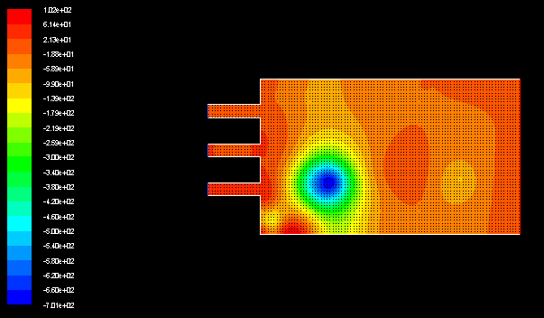
Figure 26 Contours of Static Pressure

Figure 18 shows the distribution of the static pressure of the mixture inside the combustion chamber. As shown above, the pressure of the fluids in the inlets have been given the same value.

The high pressure at the region of the inlet has been caused to the turbulence when different fluids interact and form a mixture. There is a progressive drop in the pressure as shown below. This is due to the fact that diesel as a liquid, must atomise and the energy required for diesel to atomise is taken from the latent heat of vaporization from the surrounding air and bio-gas mixture.

The figures 27, 28, 29 show further inferences made due the pressure contours as well as the variation of pressure with distance.

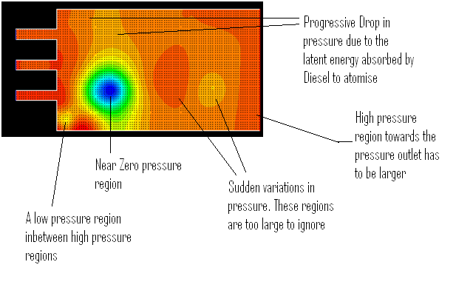
Figure 27 Highlights of Pressure contours

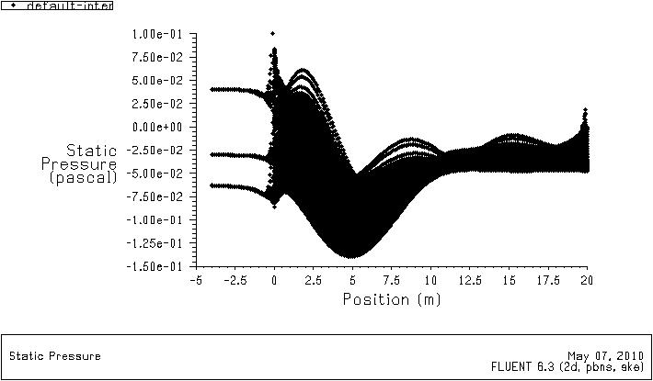
Figure 28 Variation of Static Pressure with distance
Initially, the pressure is high. This is likely due to the clashes of 3 different fluids mixing together causing a lot of turbulence. Especially even more considering that they are all different fluids with different properties i.e a multi phase mixture.
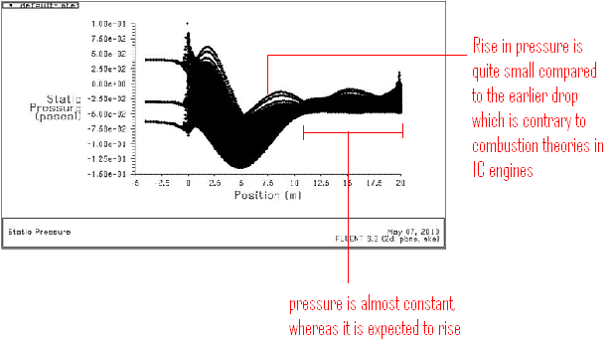
Figure 29 Highlights of the pressure variation with distance
As we can see in figure 28 and 29, the variation of the static pressure is not very favorable for efficient combustion , that too in a CI engine where the fuel is ignited due to attainment of a certain pressure. The intial pressure drop can be attributed to the atomization of the fuel and the physical and chemical delay. However, towards the end of the chemical delay, self ignition temperature is expected to be achieved and so , the pressure must drastically increase.

But from the graph we can see that the rise in pressure after the position of 5 meters is not as high as expected and relatively lower than the drop in pressure at the position of 2.5 meters.

This can be correlated with the temperature and the velocity results as well.

6.3 Turbulence – Contours :
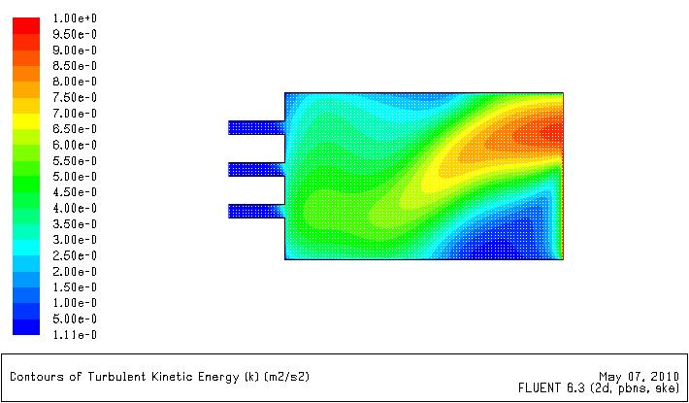
Figure 30 Contours of Turbulent Kinetic Energy
It can be seen from the figure that the fluids at the inlets enter at nearly zero turbulence or flows closer to laminar/transient flows. After which the central region of the chamber has a higher turbulence than along the boundary walls. The turbulence has slowly increased till the pressure outlet. However, the region of turbulence , near the pressure outlet is too small. It indicates that the turbulence, is achieved very late in the mixture and only at certain areas. That would mean that the entire mixture has not ignited properly.

Figure 31 Highlights -Turbulence - Contours

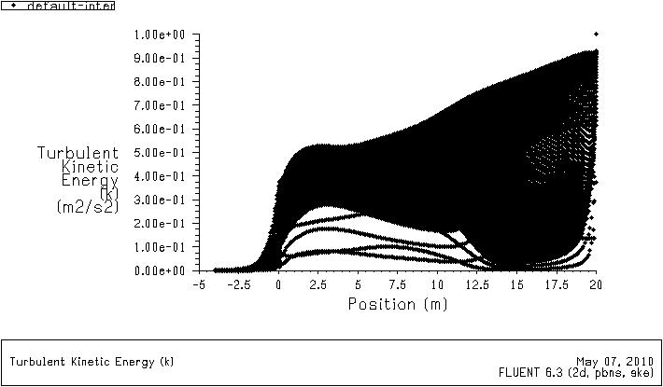
Figure 32 Variation of turbulence with Distance

The turbulent kinetic energy has one sudden and sharp rise at the distance of 0 where, the fluids meet and turbulence is caused by the mixing of the different fluids. After which, the turbulence mellows down a little as the mixing takes place. After which there is a steady rise in the kinetic energy of the turbulent mixture.

  - Static Temperature contours :
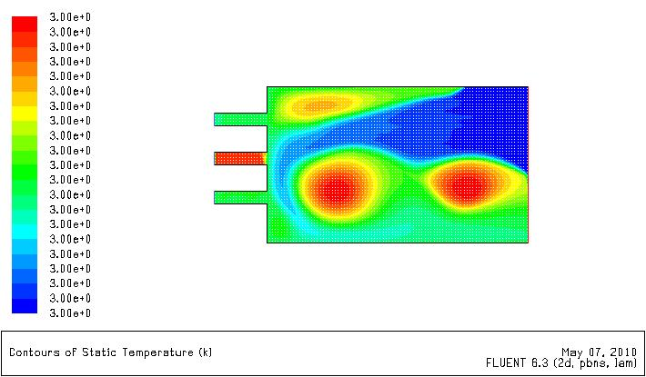
Figure 33 Static Temperature contours
Fig 29 showing the contours of the temperature is probably the most unfavorable among the results shown so far. The variation in temperature is not satisfactory. As shown above, there are only two relatively small regions in the combustion chamber that attain the highest temperature. The maximum temperature is being attained over very small regions in the chamber whereas it would be preferable for much larger regions of high temperature.
A large region in the combustion chamber and especially towards the pressure outlet, possesses very low temperature. This again indicates problems in the mixing of the fluids.

As shown in the results above, one of the inlets, namely biogas is at a higher temperature than the other inlets. This is an anomaly and it is possible that a backlash of the combustion has occurred and it has affected the biogas inlet more than the other inlets.

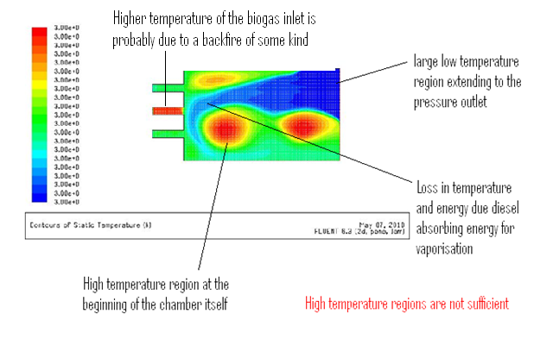
Figure 34 Highlights of the temperature contours
  - Iterative Convergence Graphs :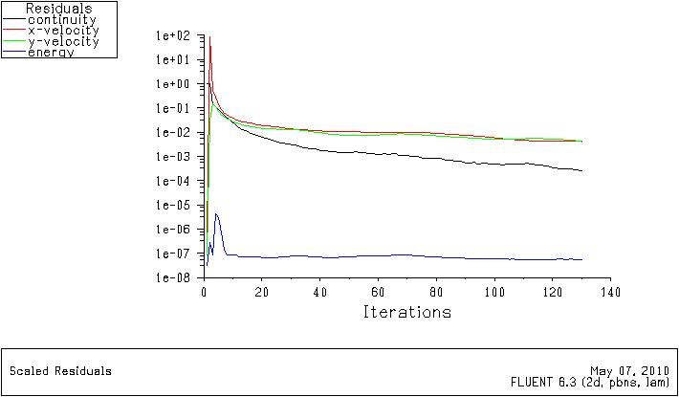
Figure 35 Residuals Graph – Low number of Iterations
A trial run was made to verify the accuracy or correctness of the results obtained from the simulation. A Low number of iterations numbering 140 were made to gauge the accuracy of the results being generated. The graph showed sufficient convergence for the simulation to proceed albeit with some refined parameters.

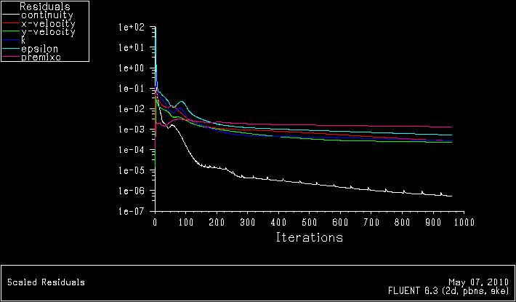
Figure 36 Residuals Graph after 1000 iterations. Final Graph

The Final Residuals graph is shown above with a 1000 iterations. As per our expectations the graphs have converged to show that the results obtained are reasonably accurate. Though the error is on the higher side, it will not change the outcome of the results to a noticeable extent.

It should be understood here that shortcomings in the geometry of the model and lack of data about the exact value of velocity and pressure inside a combustion chamber have been compensated in fluent (Thanks to Dr. Ugur Guven). There is no doubt that the results obtained are basically correct and that,the choice of parameters were reasonably correct.

Further studies would be required for more accurate results as there are a lot of parameters that could be changed. These changes and their expected results will be discussed subsequently.

  - Further Inferences and Conclusion:
The above simulation indicates that the combustion characteristics of diesel and biogas with the parameters adopted are not very favorable. There are issues in the mixing of the different fuels. The fuels are different but it is expected that a homogeneous mixture composition is achieved before combustion takes place to facilitate efficient combustion.

However, there are many indications that a change in the parameters adopted could effect a noticeable difference in the results.

Suggested changes in parameters and their expected effects :
- Changing the velocity of the fluids entering the combustion chamber : It could be interesting to increase the velocity of air and biogas, much higher than diesel. Since diesel is the liquid being atomized by the gases, the velocity of air and biogas enable quicker atomization and thus a better combustion mixture could be attained much more quickly.

- Changing the instant of entry of the fluids : As it is known, Air helps atomise the liquid diesel particles by providing the latent energy of vaporization. It could change results, if diesel is allowed to enter along with air after which bio gas could be made to enter at higher pressure to quickly mix with the atomized diesel. However, this would not guarantee the complete utilization or efficient utilization of the mixture. There would be very less time for the bio gas to enter and mix with diesel and sending biogas in at high pressure would only serve to increase the turbulence of the whole mixture.

- Inlet Pressure : The effects of pressure have been discussed in the previous point.

- Position and number of the Inlets : The position and inclination of the inlets could be varied to facilitate better mixing. Biogas could be injected at specific points in the chamber to help in better mixture attainment. Another option would be to inject Diesel and let it be atomized by Biogas and using air as a fluid stirrer.

- Changing the Orientation of the inlets : The inlets could modeled at some predecided angle that would facilitate better mixing of the various fluids. Orientation could induce swirl motions with the help of the contours of the combustion chamber surface. The fluids would move with a tangential velocity directed by the surface of the chamber.

- Combustion Chamber model : A better model of the combustion chamber could be made to induce more swirl in the mixture and enable better mixing characteristics. The objective would be to direct the flow of the mixture in a way to facilitate better mixing and flow characteristics. A nozzle could be modeled for a fuel injector for diesel. It is also evident that the mixing area is not sufficient. A larger mixing area with improved geometry could be incorporated.

Simulating the above parameters is a complicated procedure as each parameter has to be kept constant while varying the remaining parameters. This is a time consuming process. There are nearly 3000+ combinations that can be tried to determine more accurate combustion characteristics of the diesel and bio gas mixture. As explained before, added to these difficulties is the fact that this is a multi-phase simulation. It would take a huge amount of computing power and time to simulate all the above combinations.

However as shown from the converging residuals or error graphs in figure 33 , the results obtained are reasonably accurate. Considering the scarcity of Fossil fuels like diesel and petroleum, biogas is an attractive alternative and the results do not eliminate biogas as an optional fuel in the future.

From the above results, it could be concluded that further study is required to determine conclusively, characteristics of the combustion dynamics of a biogas and diesel mixture.

